BOARD OF INTERMEDIATE AND SECONDARY EDUCATION HYDERABAD (SINDH)

HSC PART-II (CLASS-XII) ANNUAL EXAMINATION 2015

FIRST THREE POSITION HOLDER’S

HUMANITIES GROUP

SR. NO. | SEAT NO. | NAME | FATHER’S NAME | NAME OF INSTITUTION | MARKS OBTAINED OUT OF 1100 | PERCENTAGE | RANK | PICTURE
 | 118223 | FIZA | MUSHTAQUE AHMED | GOVT. H/SEC: SCHOOL KHABAR LAKHMIR | 831 | 75.55 | 1ST | 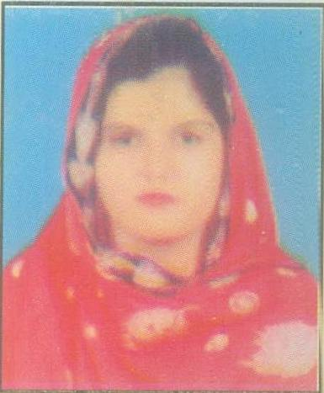
 | 121360 | ALI HASSAN | PHOTO KHAN | GOVT. H/SEC: SCHOOL DOUR | 801 | 72.82 | 2ND | 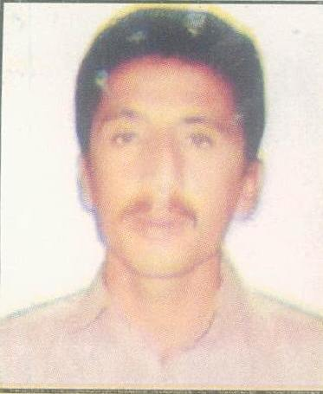

FIRST THREE POSITION HOLDERS
HUMANITIES GROUP

SR. NO. | SEAT NO. | NAME | FATHER’S NAME | NAME OF INSTITUTION | MARKS OBTAINED OUT OF 1100 | PERCENTAGE | RANK | PICTURE
 | 117674 | ABDUL HAFEEZ | WASAND KHAN | GOVT. H/SEC: SCHOOL DOUR | 801 | 72.82 | 2ND | 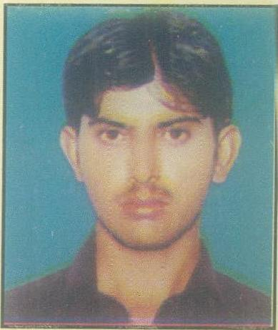
 | 121366 | AHSAN ALI | ABDUL SATTAR | GOVT. H/SEC: SCHOOL DOUR | 795 | 72.27 | 3RD | 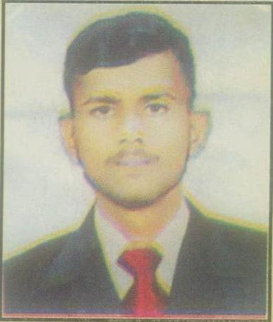

NOTE:

1. Every care has been taken to see that the results are accurate. The Board does not hold itself responsible for any omission or
mistake of printing etc; by the press while announcing this result in their Newspapers.

2. The Board reserves the right of rectifying any mistake in the result at any time on the basis of original record.

DATED:23-09-2015.  HYDERABAD SINDH | (DR. MASROOR AHMED ZAI)  CONTROLLER OF EXAMINATIONS

