BOARD OF INTERMEDIATE AND SECONDARY EDUCATION HYDERABAD (SINDH)

HSC PART-II (CLASS-XII) ANNUAL EXAMINATION 2015

FIRST THREE POSITION HOLDER’S

PRE-MEDICAL GROUP

SR. NO. | SEAT NO. | NAME | FATHER’S NAME | NAME OF INSTITUTION | MARKS OBTAINED OUT OF 1100 | PERCENTAGE | RANK | PICTURE
 | 87935 | ROHA SAEED MEMON | MUHAMMAD SAEED MEMON | SUPERIOR COLLEGE OF SCIENCE LATIFABAD HYDERABAD. | 950 | 86.36 | 1ST | 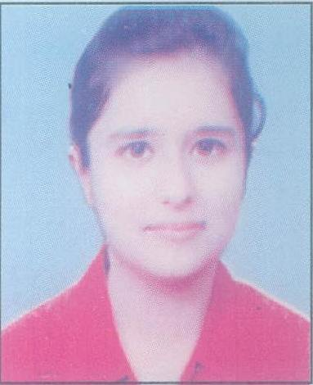
 | 87917 | KHANSA ALI | GHULAM ANWAR | SUPERIOR COLLEGE OF SCIENCE LATIFABAD HYDERABAD. | 948 | 86.18 | 2ND | 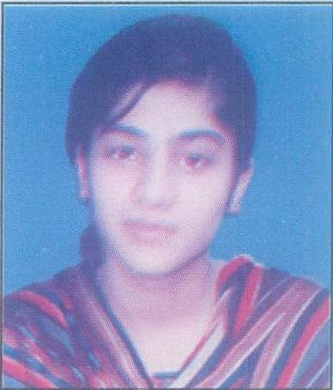

BOARD OF INTERMEDIATE AND SECONDARY EDUCATION HYDERABAD (SINDH)

HSC PART-II (CLASS-XII) ANNUAL EXAMINATION 2015

FIRST THREE POSITION HOLDER’S

PRE-MEDICAL GROUP

SR. NO. | SEAT NO. | NAME | FATHER’S NAME | NAME OF INSTITUTION | MARKS OBTAINED OUT OF 1100 | PERCENTAGE | RANK | PICTURE
 | 86100 | SADHNA | DR:ASHOK KUMAR ASNANI | HAYAT GIRLS H/SEC: SCHOOL HYDERABAD. | 941 | 85.55 | 3RD | 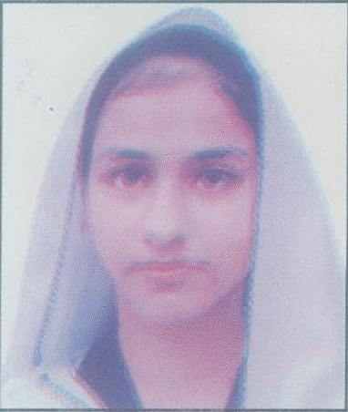

NOTE:

1. Every care has been taken to see that the results are accurate. The Board does not hold itself responsible for any omission or
mistake of printing etc; by the press while announcing this result in their Newspapers.

2. The Board reserves the right of rectifying any mistake in the result at any time on the basis of original record.

DATED: 05-09-2015.  HYDERABAD SINDH | (DR. MASROOR AHMED ZAI)  CONTROLLER OF EXAMINATIONS

