BOARD OF INTERMEDIATE AND SECONDARY EDUCATION HYDERABAD (SINDH)

SSC PART-II (CLASS-X) ANNUAL EXAMINATION 2016

FIRST THREE POSITIONS ON THE WHOLE
GENERAL GROUP

SR. NO. | SEAT NO. | NAME | FATHER’S NAME | NAME OF INSTITUTION | MARKS OBTAINED OUT OF 850 | PERCENTAGE | RANK | PICTURE
1. | 163027 | SAIMA PARVEEN | MUHAMMAD HASHIM | GOVT: GIRLS HIGH SCHOOL DAUR, NAWABSHAH | 680 | 80.00 | 1ST | 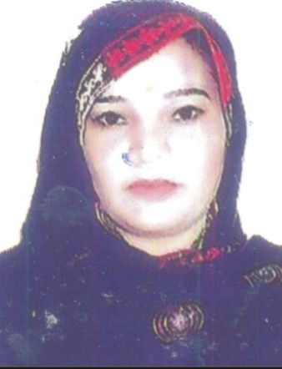
2. | 162176 | IMRAN ALI | ABDUL QADIR | M.G GOVT: HIGH SCHOOL HALA NEW | 680 | 80.00 | 1ST | 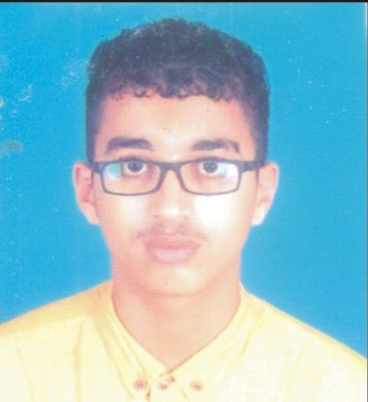
3. | 162204 | KHUNAID | MUHAMMAD USMAN | M.G GOVT: HIGH SCHOOL HALA NEW | 672 | 79.06 | 2ND | 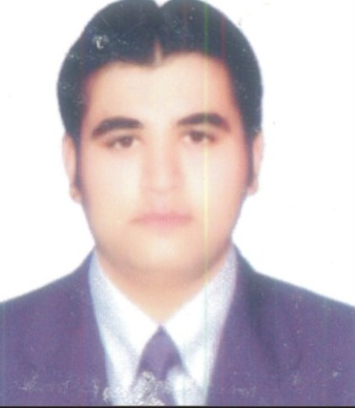
4. | 160057 | MUHAMMAD AYOOB | WAHID BUX | GOVT: HIGH SCHOOL MEHAR ALI JAMALI NAWABSHAH | 671 | 78.94 | 3RD | 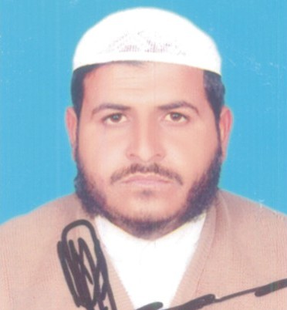

NOTE:

- Every care has been taken to see that the results are accurate. The Board does not hold itself responsible for any omission
or mistake of printing etc; by the press while announcing this result in their Newspapers.

- The Board reserves the right of rectifying any mistake in the result at any time on the basis of original record.

DATED: 28-07-2016  HYDERABAD SINDH | (DR. MASROOR AHMED ZAI)  CONTROLLER OF EXAMINATIONS

