BOARD OF INTERMEDIATE AND SECONDARY EDUCATION HYDERABAD (SINDH)

SSC PART-II (CLASS-X) ANNUAL EXAMINATION 2016

FIRST THREE POSITIONS ON THE WHOLE
SCIENCE GROUP

SR. NO. | SEAT NO. | NAME | FATHER’S NAME | NAME OF INSTITUTION | MARKS OBTAINED OUT OF 850 | PERCENTAGE | RANK | PICTURE
 | 146399 | ERUM AZIZ | AZIZULLAH | YASIR PUBLIC H/SCHOOL GULSHAN-E-IBRAHIM COLONY SEHWAN ROAD DADU | 764 | 89.88 | 1ST | 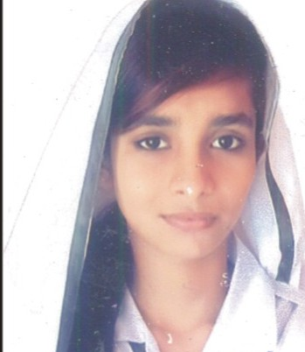
 | 139124 | IBADULLAH | ASIF IQBAL | CADET COLLEGE PETARO | 763 | 89.76 | 2ND | 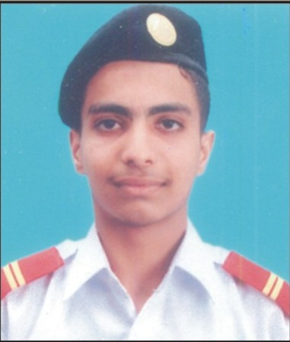
 | 132839 | MUJEEB UR REHMAN | ALLAH WARAYO | GOVT: FAQIR GHULAM RASOOL H/S/SCHOOL JAM SAHIB, NAWABSHAH | 756 | 88.94 | 3RD | 

NOTE:

1. Every care has been taken to see that the results are accurate. The Board does not hold itself responsible for any omission or
mistake of printing etc; by the press while announcing this result in their Newspapers.

2. The Board reserves the right of rectifying any mistake in the result at any time on the basis of original record.

DATED: 28-07-2016  HYDERABAD SINDH | (DR. MASROOR AHMED ZAI)  CONTROLLER OF EXAMINATIONS

