BOARD OF INTERMEDIATE AND SECONDARY EDUCATION HYDERABAD (SINDH)
HSC PART-II (CLASS-XII) ANNUAL EXAMINATION 2015

FIRST THREE POSITION HOLDERS
HOME ECONOMICS GROUP

SR. NO. | SEAT NO. | NAME | FATHER’S NAME | NAME OF INSTITUTION | MARKS OBTAINED OUT OF 1200 | PERCENTAGE | RANK | PICTURE
1. | 59012 | AMARA / ZAHRA | MUHAMMAD HUSSAIN, RATIONWALA | DR. I.H. ZUBERI COLLEGE OF HOME ECONOMICS HYDERABAD | 969 | 80.75 | 1ST | 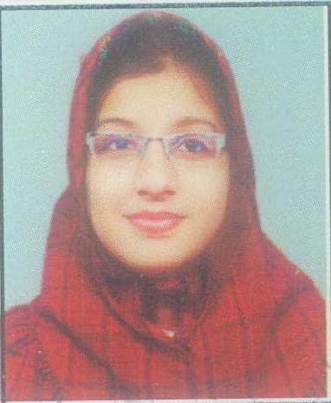
2. | 59013 | AEMAN AYOUB | MUHAMMAD AYOUB, MUGHAL | DR. I.H. ZUBERI COLLEGE OF HOME ECONOMICS HYDERABAD | 930 | 77.50 | 2ND | 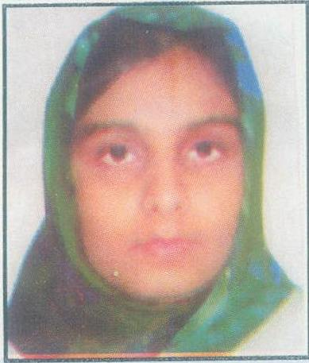

FIRST THREE POSITION HOLDERS
HOME ECONOMICS GROUP

SR. NO. | SEAT NO. | NAME | FATHER’S NAME | NAME OF INSTITUTION | MARKS OBTAINED OUT OF 1200 | PERCENTAGE | RANK | PICTURE
3. | 59026 | HUNZA | DR. RASHEED AHMED,SOOMRO | DR. I.H. ZUBERI COLLEGE OF HOME ECONOMICS HYDERABAD | 898 | 74.83 | 3RD | 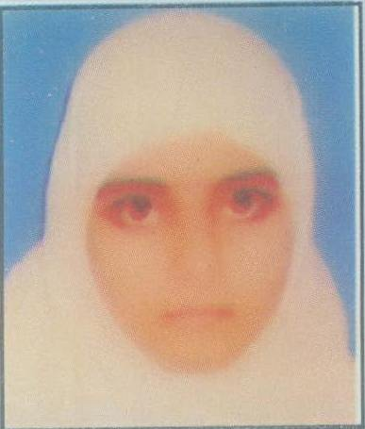

NOTE:-

1. Every care has been taken to see that the result is accurate. This Board does not hold itself responsible for any omission or mistake of printing etc; by the Press, while announcing this result in the Newspapers.

2. This Board reserves the right of rectifying any inadvertent error or omission in the result at any time on the basis of original record.

DATED: 23-09-2015.  HYDERABAD SINDH | (DR. MASROOR AHMED ZAI)  CONTROLLER OF EXAMINATIONS

